Carpentry 10 – 3 credit
Mr. Connell
Room# 139
Highwood High School

An Introductory level course for grade 10 students or 1st timers. Students develop basic hand / power tool skills, production skills, and drawing/estimating skills to safety develop products made from wood. This course is a pre-requisite for future advancement at the 20/30 level

Modules to be explored:
CON1120 Product Management – Students develop basic shop drawing and estimating skills and apply them to a product.
CON1010 Construction Tools & Materials – Students develop basic hand tool and production skills to transform common building materials safely into useful products.
CON1130 Solid Stock Construction – Students basic hand and power tool skills to build a product made from solid wood.

Focus Time:
This is an opportunity to continue project work, learn new skills, and/or receive needed assistance.

Module Evaluation:
30% Bench mark (basic competencies)
Fundamental Skills
Communication, Information Management, Thinking & Problem solving,
Personal Management Skills
Responsibility, Adaptability, Safe work practices, Work
ethic.
Team Work Skills
Working with others, participation in projects & tasks.
50% - Projects (practical hands on building skills)
20% - Written work - assignments, patterns & quizzes/tests

Project Work:

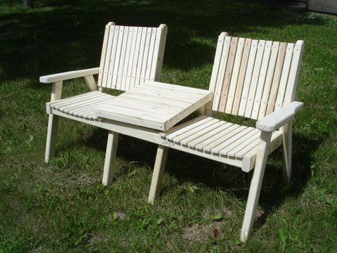
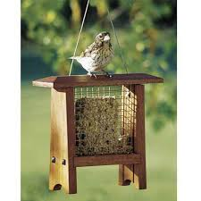
Garden Bench
Suet Bird Feeder

Semester Timeline:
- Week 1-3 CON1120Project Management.
*Assignment Questions
*Moodle Work (Unit questions)
*Unit 2 & 4 Quizzes & Final Test
- Week 4-6 CON1010 Construction Tool & Material Safety.
*Tool Safety Review – Quizzes & Test
*Starter Project Construction
- Week 7-18 CON1130 Solid Stock Construction
*Module Questions/Answers
*Garden Bench construction

Woodshop Expectations:
Acquaint yourself with Highwood’s student expectations. The following are specific for Mr. Connell’s woodworking classes.
- Beverages – Bottled water, coffee, and tea are acceptable. Ensure tight fitting lids.
- Washroom Use - Notify Mr. Connell prior to use. Please use the washroom outside this room.
- Act Responsible - This room is filled with harmful equipment. Horseplay is never tolerated. You will be held accountable for your actions.
- Preparation – Arrive to class on time & prepared. Binder/duo-tang, pencil & pen are necessary every class.
- Appropriate Clothing – Make use of smocks. Footwear to fully cover feet is necessary. Tie back long hair, remove loose jewelry.
- Safety Glasses – Mandatory for all in the room. Glasses are available. Please return at the end of clean-up for next classes use. Personal safety glasses need to be approved by your instructor.
- Phones – Turn off your phone to eliminate its distractions.
- Clean-Up – During practical work days all work together with the management of cleaning. An orderly, well maintained shop is a safe environment. Expect a mid-semester and semester end clean-up.
- Moodle –Assignment work, safety tests and unit quizzes are provided on Moodle. Use this to stay on top of your studies by reviewing upcoming lessons, related videos, documents, or catching up on missed work.
- Project Storage- cabinets for project storage is available; please ensure you put your work away at the end of each class.
- Respect- Please value your work, and that of others. Exercise caution.
- Extra Project Fees – some projects require extra fees for necessary fitted parts/pieces.
- Communication- Please ask me for assistance when in need, or when concerns arise. Routine home communication advising parent/s of work in the shop.
- Tool Use- please use the tools/machines that you have been instructed to use during class time. Many machines will need specific instruction, and knowledge testing prior to use.
- Success- It takes commitment, and plenty of hard work. Accept that mistakes will be made, but learning from them is key.

General Shop Safety
- Instructor approval must be obtained for work on all machines.
- Report all injuries, however slight, to your instructor immediately.
- Wear eye protection as required.
- If your hairstyle presents a potential hazard, you must fasten it securely or wear a protective hair cover.
- Suitable clothing and shoes must be worn for all laboratory activities. Remove or fasten any loose clothing, neckties or jewelry. Roll loose sleeves to elbows.
- Obey rules concerning operators’ safety zones.
- Cooperate with your classmates in the management of your industrial arts safety program.
- Caution any student committing an unsafe act.
- Report to instructor any equipment that does not seem to work properly.
- Keep tools and material from projecting over the edge of benches.
- Use a brush to clear away dry chips. Use a rag to clean oily areas.
- Keep floor and work surfaces clear of scraps and litter.
- Wipe up immediately any liquids spilled on the floor.
- Be sure projecting drawers and doors are kept closed.
- Place oily rags and other combustible materials in approved metal containers, and empty daily.
- Use care in handling and storing large, heavy or long pieces of material.
- Wear a respirator if the operation generates dust or fumes.
- Wear ear protection when excessive noise is encountered.
- Use tools only for their intended purposes.
- In the event of an accident all production must stop, until further instruction.
- In the event of a fire please evacuate through the nearest exit and meet outside the woodshop garage door.
- Familiarize yourself with the location and the use of the emergency eye wash stations within the room.
- Safety tests must be completed and graded before work on machines begins.

