Woodworking 9 Mr. Connell Rm# 139 connelld@fsd38.ab.ca

An Introductory level course for grade 9 students. Students develop basic hand/ power tool skills, production skills, and drawing/estimating skills to safety develop products made from wood.

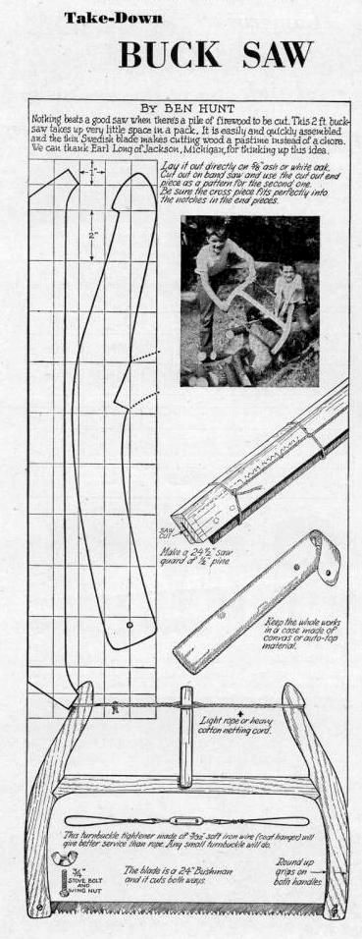
CON1010 Construction Tools & Materials – Students develop basic hand tool and production skills to transform common building materials safely into useful products. Retro-active grade 10

Projects:

Trivet

Pencil Box

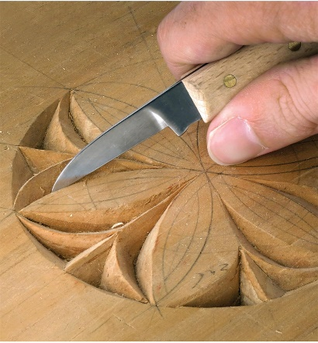

Bucksaw - with case
Woodcarving

Bow

Carpentry – Classroom Routines & Expectations

This itemized list of classroom routines & expectations is specific for Mr. Connell’s Carpentry room. Developing safe & respectful work habits is mandatory, ensuring a safe/efficient work environment. Understand and follow personal safety protocol by Alberta Heath regarding physical distancing, wearing of face masks, effective hand-sanitization, and identification of personal sign/symptoms of illness. If your sick – stay home!

Classroom Routines

- Classroom Entry & Preparation

- Enter/exit the shop only through the North Wing hallway.
- Ensure you have necessary tools for learning. Binder/Duo-Tang/Lined Paper/Pens & Pencils for coursework and note-taking & classroom activities. These items will not be provided!
- Project Work, Material Storage space will be provided for students in class.
- Safety Glasses & Masks are a necessity for each student. These will be provided Mr. Connell.

- Backpacks/Bags/Purses will be stored along project storage cabinet in the shop.

- Wash/Sanitization - Upon Immediately entering, wash or sanitize hands - repeat upon leaving.

- Assigned Seating/Workspaces - Grab a chair and sit at your assigned location. (necessary for contact tracing)

- Daily Lessons - Lectures, Demonstrations, Paper/Pencil activities, Videos, Individual Project Work. (Be sure to take regular notes)

- Shop Cleaning & Sanitization - Remaining 15minutes of class is designated towards housekeeping duties, personal cleaning & sanitization. Sanitize/restack your chair, and sanitize your work station.

- Dismissal – Daily debriefings prior to leaving. Please no congregating around shop entrances/exits. Mr. Connell will dismiss at scheduled times above.

Classroom Expectations

Just showing gets you nothing! A solid work ethic, demonstrating respect, responsibility, honesty, maturity & independence are the fundamentals for success. I don’t expect any less!
- Safety – Quizzes and tests must be successfully completed prior to machine & tool use.
- Respect – Giving attention and showing care.
- Responsibility – Horseplay is not tolerated.
- Attendance – Completed at the beginning of each class. Be on time!
- Questions & Assistance – Ask, but do it respectfully.
- Moodle – An electronic platform to regularly access course work and posted assignments. Learn it, and use it regularly. This is the platform for anything online!
- Textbooks – Reading material will be posted on Moodle for viewing purposes.
- Washroom Use – At an appropriate time as not to impede on lessons, instruction, demonstrations, etc. Raise your hand if necessary - Exit/Entry log needs to be filled out by Mr. Connell. Only use Washroom in English Wing.
- Mobile Devices – Mr. Connell will notify you when devices use is acceptable. Power off at the beginning of class and in backpacks preventing unnecessary distractions.
- Appointments – Please notify your Mr. Connell in-advance of any of any pre-scheduled medical leaves.
- Late – Notify Mr. Connell ensuring attendance is updated. Be on time!
- Food/Beverages – Beverages only with closed lids. Food not allowed.
- Clothing – Shoes that fully cover your feet.
- Communication Home – Monthly emails. You need to update parents on your responsibilities in class.
- Be a Responsible Learner – Follow the “Characteristics of Responsible learner Guidelines” posted in class.
- Coming Prepared to Work – Pre-plan your day in advance. Be on the floor ready to work and on time, working on necessary assignments & projects assigned. Finish work early – then we talk!
- Computer Lab – No access, no storage, no entering or exit to/from the shop.
- Independence – Hone this skill base, its important! Don’t rely on me holding your hand.
- Honesty – Speak the truth, or don’t speak at all!
- Maturity – Act your age and with integrity!
- Skipping – These actions show you choose not to commit.

Evaluation:
50% Bench mark (basic competencies)
Fundamental Skills
Communication, Information Management, Thinking & Problem solving,
Personal Management Skills
Responsibility, Adaptability, Safe work practices, Work
ethic.
Team Work Skills
Working with others, participation in projects & tasks.
30% - Projects (practical hands on building skills)
20% - Written work - assignments, patterns & quizzes/tests

Time Line:
- Introduction, Outline, Projects, Moodle 1day
- General Safety, Machine Safety, Safety Videos 4 days
- Unit 3,5,7,15 Questions/Quizzes 5 days
- Safety Test 1 day
- Measuring assignments 2 days
- Tool Identification assignment 2 days
- Kitchen Utensil & Pencil Box construction 5-7 days
- Major Project/s instruction & construction 6 weeks

General Shop Safety
- Instructor approval must be obtained for work on all machines.
- Report all injuries, however slight, to your instructor immediately.
- Wear eye protection as required.
- Facemasks as required.
- If your hairstyle presents a potential hazard, you must fasten it securely or wear a protective hair cover.
- Suitable clothing and shoes must be worn for all laboratory activities. Remove or fasten any loose clothing, neckties or jewelry. Roll loose sleeves to elbows.
- Obey rules concerning operators’ safety zones.
- Cooperate with your classmates in the management of your industrial arts safety program.
- Caution any student committing an unsafe act.
- Report to instructor any equipment that does not seem to work properly.
- Keep tools and material from projecting over the edge of benches.
- Use a brush to clear away dry chips. Use a rag to clean oily areas.
- Keep floor and work surfaces clear of scraps and litter.
- Wipe up immediately any liquids spilled on the floor.
- Be sure projecting drawers and doors are kept closed.
- Place oily rags and other combustible materials in approved metal containers, and empty daily.
- Use care in handling and storing large, heavy or long pieces of material.
- Wear a respirator if the operation generates dust or fumes.
- Wear ear protection when excessive noise is encountered.
- Use tools only for their intended purposes.
- In the event of an accident all production must stop, until further instruction.
- In the event of a fire please evacuate through the nearest exit and meet outside the woodshop garage door.
- Familiarize yourself with the location and the use of the emergency eye wash stations within the room.
- Hazard Assessment & Work Site Safety Inspection sheets must be completed, and returned to your instructor prior to any work.
- Safety tests must be completed and graded before work on machines begins.

Woodshop Safety Guide
Objectives
Working in the woodshop is intended to broaden and enhance your planning and production skills. You will learn safety procedures, organization, planning and execution of short term and long term projects, cooperation with others, and knowledge of woodcarving tools/machines. Furthermore, through an application of strict work ethics, you can and will develop self-respect, maturity, and confidence that come with fine workmanship and concrete success. You are expected to complete all course work. Manage your time wisely – make use of all class time and optional FOCUS TIME on available days.
The bottom line is to build knowledge & skills related woodworking tools, machines and materials in an efficient & safely manner. Zero tolerance for unsafe practices and misbehaviors. Violations to Safety Rules will be followed strictly and immediately.
You are required to pass a safety test of 80% accuracy. Any mark below 80% will require a rewrite. It is Mr. Connell’s responsibility to ensure you receive necessary safety instruction for tool/machine and shop safety but your individual responsibility to practice these safe practices

Woodshop Safety Rules
Due to the nature of working in the woodshop you must exhibit responsibility at all times for yourself and your classmates. Irresponsible and reckless behavior in the woodshop will be treated swiftly. Consequences will be enforced strictly and appropriately. You are expected to follow these guidelines. If there are any questions about the safety procedures you must immediately voice your concerns to Mr. Connell.
I (name)______________________________________ understand the use and operation of tools / machines is a privilege and a responsibility that I must earn and maintain through demonstration. Blades are honed extremely sharp to ensure ease of use, and safety. Misuse, lapse in good judgment, avoidable distractions or forgetfulness will cause serious injury.
________________________________________
Students Signature

