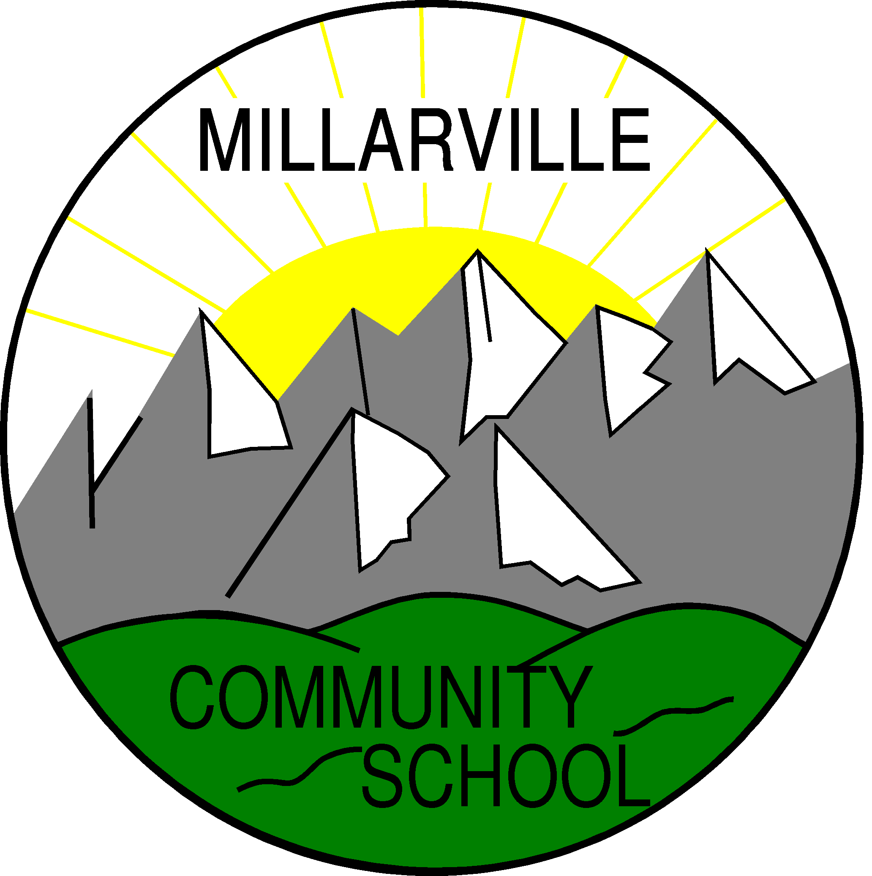

Assessment Policy

To create a caring, challenging, and engaging learning environment which reflects the values and vision of the International Baccalaureate and Foothills School Division.
We strive to inspire and empower our students to think creatively and critically, pursue lifelong learning, and contribute positively to the global community.
Principles of Assessment at Millarville Community School

The ultimate goal of our schools is to impact student learning in a positive way.
Research into the relationship between student learning and assessment can be summarized as follows:

- Assessment must be transparent in its purpose.
- Assessment criteria are established and shared with students beforehand.
- Assessment should provide clear evidence of student learning.
- Assessment methods should be varied and match the learner outcomes of the Alberta Program of Studies.
- Assessment should be meaningful, authentic, and ongoing.
- Assessment should involve students in the process.
- Assessment needs to provide a direction to improve and guide instruction.
- Assessment tasks are appropriate for all learners.

Assessment is the process of gathering evidence and making inferences about student learning for a variety of purposes. Within the framework of the IB Primary Years Programme we assess student understanding and/or development of:

• The IB Essential Elements (knowledge, concepts, skills, attitudes, action)
• The Central Idea in a Unit of Inquiry
• The IB PYP transdisciplinary theme as it relates to the central idea in a Unit of Inquiry
• Learning Standards and Core Competencies for subject areas as mandated by the Alberta Program of Studies
•Attributes of the Learner Profile

Assessment in the PYP is accomplished by emphasizing connections between subject-specific knowledge and transdisciplinary skills, key concepts, central ideas, and themes. Assessment shows us what the student knows, understands, and can apply throughout the learning process. We assess these components through:

• Student’s daily work/assignments and discussions
• Summative assessment tasks

Beliefs

We believe assessment should:

- lead to reflection about learning
- allow for student choice and put the student at the centre
- involve teachers, students, peers and parents
- be varied – using a variety of tools and strategies, both formal and informal • Be done formatively as well as summatively
- allow for all students to be successful
- be differentiated according to the needs of students
- provide opportunities for students to demonstrate understanding and broad interpretation of concepts learned
- be transparent to all stakeholders – with clear criteria for success
- assess all elements of the programmes offered – not just knowledge and skills
- drive instruction, guide learning and inform curriculum planning
- provide opportunities to give timely feedback on the learning process

Summative assessment
Summative assessment is the culmination of the teaching and learning process and gives the students opportunities to demonstrate what has been learned. It can assess several elements simultaneously: it informs and improves student learning and the teaching process; it measures understanding of the central idea, and prompts students towards action.

Summative assessment provides varied opportunities for the students to show their understanding of the central idea and appropriate assessment tasks are designed with this in mind.

Formative assessment
Formative assessment provides information that is used in order to plan the next stage in learning. It is interwoven with learning, and helps teachers and students to find out what the students already know and can do so that further provocations can be provided in order to improve knowledge and understanding. Teachers strive to ascertain students’ prior knowledge so as to provide them with challenging provocations and experiences to further construct meaning.

Assessment tools and strategies
We use a wide variety of assessment tools and strategies, always aiming for
the tool or strategy that is most appropriate and will give us the most reliable
information. We aim to give all students the opportunity to be successful and
to be able to show what they know, can do and understand. Samples of tools
and strategies are: observation, written responses, rubrics, checklists or
exemplars.

Type of Assessment | Classroom Examples | How is this recorded | How is this analyzed | How is this reported | Who is responsible
Formative  (Diagnostic and On-going) | Class observations, Mind Map / Web, Vocabulary Awareness, Thumbs Up/Down/Sideways, Brainstorming, KWLH – Know/Wonder/Learn/How, Class discussion - Think-Pair-Share, Inside/Outside, Cut the Line/Value Line, Popcorn, 4 Corners, Placema, Ticket Out the Door, Carousel brainstorming, Gallery walk, Quick write or draw, Learning logs and journals, Conferences (teacher/peer), summary, Developmental continuum, portfolios, conversations, | Anecdotal record, checklist, rubrics, | Used to monitor progress towards unit goals and inform instruction | Shared between teachers and students in order to further learning (not graded). Can help with informal parent conferences. | Teachers, students
Summative | Performance tasks, self assessment, teacher made tests, Portfolios, or any of the above listed strategies | Standard rubric, checklists, performance standards, anecdotal records | Compared to established criteria Long term trends can be used for school planning | Shared with students through class activities and parents with formal reports, overall trends reported to administrators | Teachers, students, administra -tors

Reporting

Milarville Community School follows the following reporting cycle throughout each
school year:

October/November: Parent Teacher Conferences
Parents are invited to meet with their child’s teachers to discuss academic
progress and social-emotional development of the student so far in the school
year. Conferences are 15 minutes in length and teachers will share evidence of progress and strategies for next steps, as well as address ways in which parents can support their child at home.

December and March: Foothills School Division Learner Profiles/Report Cards
This district mandated written report includes information about the Alberta mandated curriculum as well as information about the PYP and the term’s units of inquiry.

March/April: Student Led Conferences

During Student Led Conferences, students lead their parents through a thirty minute long conference, using their portfolios and work samples as tools to share their learning. Students share their successes and their challenges, and guide their parents through some typical learning experiences in different curriculum areas. Student Led Conferences aim to help students become confident and reflective learners. Teachers play an active role during the preparation for these conferences, but do not conference with parents on this day, to ensure ownership stays with the students.

Standardized/Level A Assessments

At MCS, we use a range of standardized assessment tools to help plan for learning and to measure progress made. Teachers use this information with the many other ways they collect data about children’s learning.

The following provides an overview of these assessment tools:

Tool | Who | When | Purpose
Early Years Evaluation Tool | Kindergarten | November | To assess five aspects of early child development that are closely related to school preparedness and emergent literacy skills:
DRA reading assessment or other similar informal reading inventory | Grade 1 - 5 | September and May | To determine reading level to plan for instruction
Developmental Spelling | Grade 1 | September and May | To determine developmental spelling level to plan for instruction
Schnoell Spelling | Grade 2 – 5 | September and May | To determine developmental spelling level to plan for instruction
Frontenac Math | Grade 2 – 5 | September and May | To measure procedural and computational abilities
Math Intervention Programming Instrument (MIPI) | Grade 2 – 5 | September | To find out where students are in knowledge, concepts, and skills of previous year
Portfolios

An MCS portfolio is a collection of student work specifically selected to tell a story about the learning journey and the growth of the student. It is an assessment tool that documents growth in the units of inquiry.

Students in the PYP have a six-sectioned folder that travels from grade-to-grade with the child. Teachers and students put examples and artifacts of the unit of inquiry summative assessments. These folders are shared with parents during Student Led Conferences as well as at the end of the year. The folders stay in the school until Grade 5, where they are sent home with students as a record of their time in the PYP at MCS.

Celebrations of Learning

At various times throughout the school, students showcase their learning based on a current Unit of Inquiry. These opportunities are intended to support the development of the IB Learner Profile attributes by encouraging students to reflect on their accomplishments and learning journey and to help students become effective communicators.

Assessment of PYP Learner Profile Attributes

Students are informally recognized for their development of IB Learner Profile attributes in the classroom and at school-wide assemblies. They are provided with opportunities to reflect on their personal growth of the Learner Profile attributes through various methods such as self-reflection, self-assessments, and student journals. Staff members use the language of the IB Learner Profile to model appropriate words and actions that exemplify and explicitly teach and reinforce the attributes. The Learner Profile is infused throughout daily conversations and in the taught curriculum.

Parents are informed of their child’s development of these attributes through report card comments, student self-assessments and during student-led conferences and parent-teacher meetings. Our School Council has also developed Essential Agreements using the language of the Learner Profile.

Communication Plan

The staff at MCS believes strongly in the need to develop an effective communication plan. As an International Baccalaureate (IB) World School, our staff, students, and school community members are encouraged to demonstrate the attributes of the IB Learner Profile to become internationally minded citizens. These ten attributes - inquirer, thinker, balanced, reflective, communicator, knowledgeable, caring, principled, open minded, tolerant - form the basis of our school’s essential agreements. To that end, we agree that effective communication is a shared responsibility between all of the partners who make up the school community. Consistent, daily communication promotes transparency. Research has shown that effective communication is an integral component of successful educational programs. Effective communication plans must ensure the free flow of information in both directions between the home and school. It is with this in mind that the following communication plan has been developed.

Official Communication Dates

Learner Profile Dates (Report Cards)

Term 1 - December
Term 2 - March
Term 3 - June

Parent Teacher Conference Dates
Parents can set up an account anytime and book appointments closer to the following dates at: http://mcs.schoolappointments.com/
September (5:30 -7:00 p.m.) - Meet the Teacher Evening (No appointments needed)
November (3:15 – 8:30 p.m.) Traditional Parent/Teacher Conferences
March (3:30-8:30 p.m.) - Student Led Conferences/Celebration of Learning

School → Home Communication

Agendas - The MCS Fundraising Society has purchased agendas for all MCS students. These are the primary information source for daily communication home. Tests, homework and assignments are kept within this agenda during a dedicated agenda time at the end of each day. Parents can use the agenda to communicate quick notes to teachers or return forms to the school. It is encouraged that parents check into your child’s agenda regularly.

Bi-weekly Millarville Messenger - This publication provides a look ahead and a look back at happenings in the school and community. Parents will receive notification of the publication every other Monday throughout the school year. Paper copies are available in the school’s office and a digital version is available on our school website. Community articles must be in on the Friday prior to each publication in order to be included.

School Website - The school’s website is the central resource for all families. Newsletters, classroom sites, our Twitter feed and other information can be found quickly on this site. millarville.fsd38.ab.ca

Classroom Websites - Each grade has a website to update families regarding current topics of inquiry, resources for home and homework assignments. Please check in with your grade’s website regularly to keep on top of current classroom events and resources to help your child at home.

Classroom Newsletters/Emails - Many teachers email their families frequently to ensure you are abreast of the latest information and news from the classroom. Please ensure your latest email address is correct with our Office Administrator early in the year and check your spam folders to ensure you are not missing these emails.

Twitter/Facebook - MCS has a school Twitter feed to update families and our website of upcoming events, resources and photos of what is happening around the school. A Twitter account is not needed to view these tweets, simply log onto our school website to see more. @MCSWildcats or www.facebook.com/MCSWildcats

Telephone Calls - Teachers will make telephone calls to the homes of students as the need arises. These calls will be of a positive nature as well as providing an opportunity to discuss issues of concern.

Notes or Letters - From time to time parents may receive a letter or note from their child’s teacher regarding a specific issue of importance.

Permission Forms - Anytime that a class or group of students leave the school to participate in a field trip, a permission form containing the specifics of the trip will be sent home for a parent or guardian signature. It is very important that these forms come back to the school on time or your child may not be able to attend an upcoming fieldtrip. Additional forms may be found on our school website.

Memos from the Office - Memos containing information regarding specific activities will be sent home as necessary.

Home → School Communication

Parents/guardians are encouraged to maintain regular communication with the school using a variety of means. The primary point of contact about concerns about your child’s learning, social development or other points is your child’s classroom teacher. If you have contacted the teacher and feel an issue has not been resolved, please feel free to contact the principal. MCS has an open door policy and welcomes parents to our school. However, for safety reasons, we ask that you sign in at the office when you arrive. PLEASE contact the school prior to 9:00 am to report your child absent.

Agendas - Quick notes and appointments can be passed through your child’s agenda.

Telephone - Parents are able to call the school (403-938-7832) in order to obtain information or to arrange meetings with staff. Please note that teachers will not be called out of class to answer telephone calls unless they are of an emergency nature.

Meetings - Parents can arrange a meeting with a teacher or school administrator by calling the school.

E-mail - Parents are able to contact teachers via email. These email addresses are available on the school website if you require.

Essential Agreements

We agree that during the ongoing assessment process:

- all staff will be making regular contact with parents between reporting periods and at the beginning of the year
- staff will maintain an up-to-date class webpage. This update will be shared at the first Divisional meeting of each month and outline current curricular focus and units of inquiry.
- Class/grade level/ division level webpages may provide a list of URL’s that support your instruction
- we will include frequent opportunities for student self-assessment and peer-assessment
- Students will have opportunities for second chances. At the same time, students should have second opportunities for learning before a second opportunity for assessment.

We agree that when reporting student learning and results:

- each unit of inquiry will be represented on the IB insert comment sheet and will highlight:

K-5
- transdisciplinary theme, central idea, lines of inquiry, key concepts, attitudes, approaches to learning, and attributes of the IB learner profile.
6-8
- enduring understandings, essential question(s), and attributes of the IB learner profile.

- the Child as a learner section should include comments around the IB learner profile; this section may also include quotes or action pieces generated by the student
- literacy (reading and writing) and numeracy comments will be reported each term (K-4 only)
- we will report at least one area of strength related to the Alberta Program of Studies
- we will provide feedback on at least one area for improvement related to the Alberta Program of Studies. This comment should also provide parent friendly comment that supports next steps and written as strategies (i.e. this could include a URL’s that support)
- our comments will be written in a positive tone
- all language needs to be succinct and student and parent friendly

