IB Inclusion
Special Needs Policy

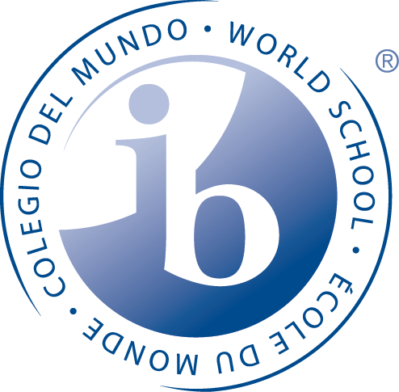

To create a caring, challenging, and engaging learning environment which reflects the values and vision of the International Baccalaureate and Foothills School Division.
We strive to inspire and empower our students to think creatively and critically, pursue lifelong learning, and contribute positively to the global community.

MCS Inclusive Education/Special Needs Policy

Under the terms of the School Act (RSA2000),(b), Alberta Education has made special provisions for the education of students with special needs. Through the years, special education programs have been developed to address the special needs of such students.

School authorities are required to provide special education programs based on Inclusive Learning Plans (ILPs) designed to meet the educational needs of identified exceptional students. Under the jurisdiction of Alberta Education, the staff at MCS provides placement plans for students who are served outside the regular classroom.
Alberta’s education system is built on a values-based approach to accepting responsibility for all children and students. Inclusion is a way of thinking and acting that demonstrates universal acceptance of, and belonging for, all children and students.
To support children and students in attaining the goals as stated in the Ministerial Order on Student Learning, school authorities must ensure that all children and students (Kindergarten to Grade 12), regardless of race, religious belief, colour, gender, gender identity, gender expression, physical disability, mental disability, family status or sexual orientation, or any other factor(s), have access to meaningful and relevant learning experiences that include appropriate instructional supports.

Principles of Inclusive Education
The following six principles are key to achieving Alberta’s vision for an inclusive education system:
Anticipate, value and support diversity and learner differences -Welcoming, caring, respectful and safe learning environments create a sense of belonging for all learners and their families.
High expectations for all learners - Creating a culture of high expectations begins with an accessible curriculum and meaningful and relevant learning experiences. Educators and families act on the idea that, with the right instructional supports, every learner can be successful.

Understand learners’ strengths and needs - Meaningful data is gathered and shared at all levels of the system—by teachers, families, schools, school authorities and the Ministry—to understand and respond to the strengths and needs of individual learners.

Reduce barriers within learning environments - All education partners work together to identify and reduce barriers within the curriculum, the learning environment and/or instruction that are interfering with students' ability to be successful learners and to participate in the school community.

Capacity building - School leaders, teachers, education professionals, families and community partners have ongoing opportunities, relationships and resources that develop, strengthen and renew their understanding, skills and abilities to create flexible and responsive learning environments. Capacity building takes place at the personal, school and system levels.

Shared responsibility - All education partners, including school and jurisdictional staff, families, community service providers, post-secondary institutions, teacher preparation programs and government are committed to collaboration and are committed to the success of all learners.

These principles strongly correlate to the following ways the IB identifies as ways to extend learning for all students:

- Create optimal learning environments that celebrate and embrace the diversity of all learners
- Use technology that is accessible to all learners
- Develop collaborative learning activities that include initiatives with shared goals and involve all members of the school community
- Promote ATLs that develop affective and metacognitive skills, and encourage students to view learning as something that they do for themselves in a proactive way
- Create accessible assessments in terms of design, content and medium
- Teach to variability, which includes differentiation and Universal Design for Learning (UDL) – a framework for curriculum development that provides all students with equal opportunities to learn.

MCS Philosophy

We believe that all learners have unique needs to consider when helping them to meet / exceed their academic and non-academic potential. To provide access to the IB Primary Years Program at MCS, we apply approaches and support systems that address the individual needs and varied learning styles of students, including those identified with special needs (special education and gifted and talented). By recognizing the diversity of our collective learning community, we support the development of internationally-minded people.

As an IB-authorized school, the staff at Millarville Community School (MCS) involves all of their students in the PYP, regardless of their learning needs. The staff supports the IB recommendation that the PYP is “whole-school approach". The staff at MCS supports each student and will make any necessary accommodation for students with special needs.

We support the following beliefs about inclusion, as stated in Learning Diversity and Inclusion in IB Programmes (January 2016)

- students are at the centre of learning and can take responsibility for their learning

- resources are made available to all students

- procedures and provisions remain consistent

- the learning environment (social and physical) lends itself to inclusion

- differentiation is supported from planning through to instruction and assessment

Our Purpose

This Inclusive Education/SEN policy guides our practice:

- to maintain open access to the Primary Years Programme for all students
- to validate and enhance the efforts of our learning community to meet the educational needs of all students
- to define the roles and shared responsibility of each stakeholder (staff, students and parents)
- to define the structures and systems needed to support all students

Our Practices

The Foothills School Division uses a Continuum of Supports model that is based on Universal Design for Learning (Ross and Meyer 2011). MCS has several formal and informal support services available, including Response to Intervention. The RTI team members include administrators, PYP coordinator, classroom teachers, educational assistant, Learning Commons Facilitator, Family School Liaison Counselor, Student Services personnel (speech, language, occupational therapy and physical therapy, psychologist). The RTI groups meet for 30 minutes per day, 4 days per week.

The RTI model is the starting point to identify and serve students who need additional academic or behavioral support to make satisfactory progress towards meeting grade level expectations. If a student does not show growth after several interventions have been tried, he/she is referred for a Level B Standardized assessment. This evaluation is conducted by the Learning Coach. If further information is required, a Level C Standardized assessment is requested. This evaluation is conducted by the Foothills School Division psychologist.

The Collaborative Problem Solving team is comprised of the Principal, the Vice Principal, the Learning Coach, and the Family Liaison. This team meets weekly to discuss identified students and/or families who require support or intervention. The Ross Greene Collaborative Problem Solving model of identifying lagging skills is the primary method of support.

In the spring of 2016, MCS staff, in consultation with the parent community, drafted the Positive Behaviour Support Plan and the MCS Continuum of Supports document. These documents comply with the Foothills School Division administrative policy.

References:
Alberta Education Program and Services
Special Education
January 2003

Alberta Education
Inclusion Policy
2015

Special Education Coding Criteria 2016-2017
Alberta Education
January 2016

Learning Diversity and Inclusion in IB Programmes
January 2016

