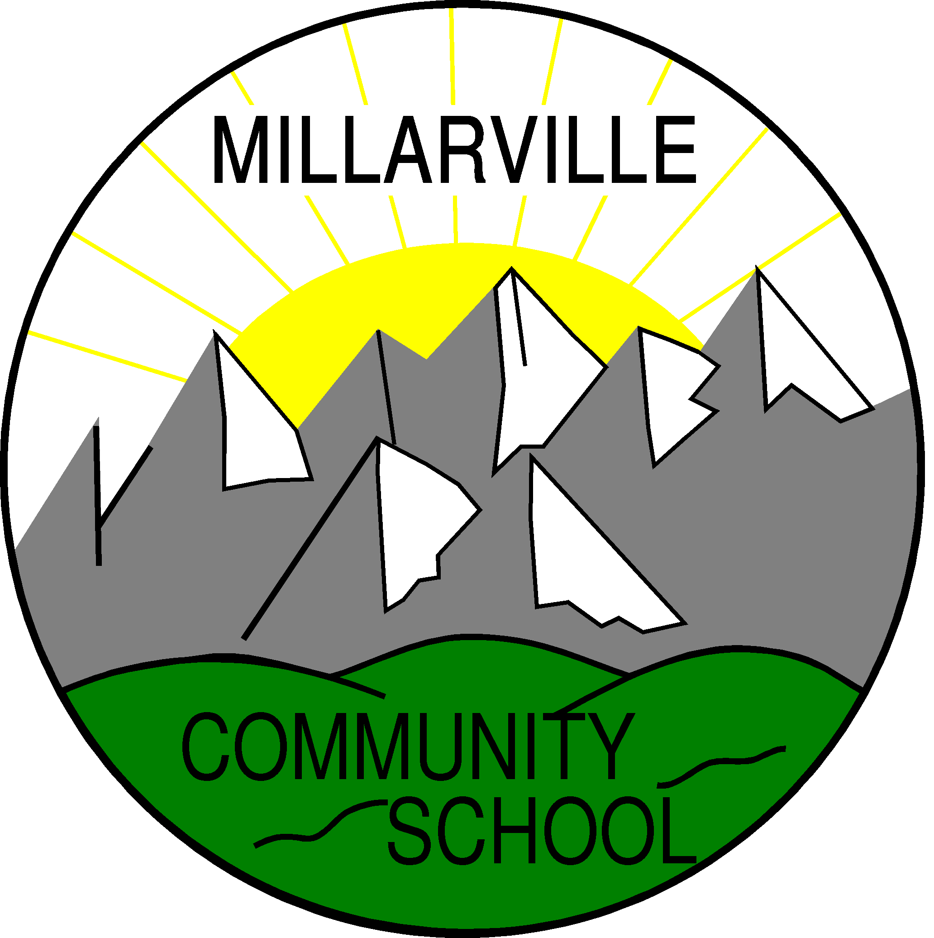

Language Policy

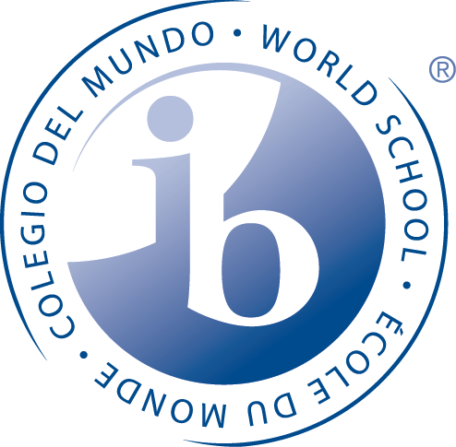

To create a caring, challenging, and engaging learning environment which reflects the values and vision of the International Baccalaureate and Foothills School Division.
We strive to inspire and empower our students to think creatively and critically, pursue lifelong learning, and contribute positively to the global community.
MCS Language Policy

Curricular Context

The following is from the Alberta Education Language Arts Programme of Studies and provides the context for Language Learning at Millarville Community School (MCS).

“There are two basic aims of English language arts. One aim is to encourage, in students, an understanding and appreciation of the significance and artistry of literature. A second aim is to enable each student to understand and appreciate language and to use it confidently and competently for a variety of purposes, with diverse audiences and in a range of situations for communication, personal satisfaction and learning.

From Kindergarten to Grade 12, students are developing knowledge, skills and attitudes in six language arts: Listening and Speaking; Reading and Writing; Viewing and Representing. Students learn to compose, comprehend and respond to oral, print and other media texts. They experience a variety of texts from many cultural traditions.

Changes in society and technology have affected, and will continue to affect, the
ways in which people use language to think, to communicate and to learn. Students must be prepared to meet new literacy demands in Canada and the international community. The ability to use language effectively enhances student opportunities to experience personal satisfaction and to become responsible, contributing citizens and lifelong learners.

Children learn language as they use it to communicate their thoughts, feelings and experiences; establish relationships with family members and friends; and strive to make sense and order of their world. They may come to school speaking more than one language or learn another language in school. It is important to respect and build upon a child’s first language. Experience in one language will benefit the learning of other languages.

Language development is continuous and recursive throughout a student’s life. Students enhance their language abilities by using what they know in new and more complex contexts and with increasing sophistication. They reflect on and use prior knowledge to extend and enhance their language and understanding.

The responsibility for language learning is shared by students, parents, teachers and the community. Students require ongoing opportunities to use language in its many forms. Opportunities to learn language occur first at home and are extended as children move into the larger community. Schools provide environments where students develop language knowledge, skills and strategies to achieve academic, personal and social goals. Language development is the responsibility of all teachers. Thinking, learning and language are interrelated.

From Kindergarten to Grade 12, students use language to make sense of and bring order to their world. They use language to examine new experiences and knowledge in relation to their prior knowledge, experiences and beliefs. They make connections, anticipate possibilities, reflect upon ideas and determine courses of action. Language enables students to play an active role in various communities of learners within and beyond the classroom. As students speak, write and represent, they also listen to, read about and view the ideas and experiences of others. Critical and creative thinking and learning through language occur when students reflect, speculate, create, analyze and synthesize.

In addition, language facilitates student development of metacognitive awareness; that is, it enables them to reflect on and control their own thinking and learning processes. Language helps students develop an awareness of the skills and strategies they need to complete learning tasks successfully and to communicate about themselves as learners.

The aim of English language arts is to enable each student to understand and appreciate language, and to use it confidently and competently in a variety of situations for communication, personal satisfaction and learning.

Students become confident and competent users of all six language arts through many opportunities to listen and speak, read and write, and view and represent in a variety of combinations and relevant contexts. All the language arts are interrelated and interdependent; facility in one strengthens and supports the others. In the outcomes of the program of studies, the six language arts are integrated.
Listening and Speaking
Oral language is the foundation of literacy. Through listening and speaking, people communicate thoughts, feelings, experiences, information and opinions, and learn to understand themselves and others. Oral language carries a community’s stories, values, beliefs and traditions. Listening and speaking enable students to explore ideas and concepts, as well as to understand and organize their experiences and knowledge. They use oral language to learn, solve problems and reach goals. To become discerning, lifelong learners, students at all grades need to develop fluency and confidence in their oral language abilities. They benefit from many opportunities to listen and speak both informally and formally for a variety of purposes.
Reading and Writing
Reading and writing are powerful means of communicating and learning. They enable students to extend their knowledge and use of language, increase their understanding of themselves and others, and experience enjoyment and personal satisfaction. Reading provides students with a means of accessing the ideas, views and experiences of others. By using effective reading skills and strategies, students construct meaning and develop thoughtful and critical interpretations of a variety of texts. Writing enables students to explore, shape and clarify their thoughts, and to communicate them to others. By using effective writing strategies, they discover and refine ideas and compose and revise with increasing confidence and skill.
Viewing and Representing
Viewing and representing are integral parts of contemporary life. These allow students to understand the ways in which images and language may be used to convey ideas, values and beliefs. Viewing is an active process of attending to and comprehending such visual media as television, advertising images, films, diagrams, symbols, photographs, videos, drama, drawings, sculpture and paintings. Viewing enables students to acquire information and to appreciate the ideas and experiences of others. Many of the comprehension processes involved in reading, such as previewing, predicting and making inferences, may also be used in viewing. Representing enables students to communicate information and ideas through a variety of media, such as video presentations, posters, diagrams, charts, symbols, visual art, drama, mime and models.
Texts
In today’s technological society, people access information and find enjoyment in print, as well as other language forms. For example, oral communication and visual media are becoming increasingly important. Often these forms are used in combination with one another and in conjunction with print. Therefore, texts refer not only to print but also to oral and visual forms that can be discussed, studied and analyzed. In addition, texts are affected and influenced by how they are transmitted, whether by computer, television, radio or book. Students need knowledge, skills and strategies in all six language arts to compose, comprehend and respond to such texts. Oral texts include storytelling, dialogues, speeches and conversations. Visual texts include pictures, diagrams, tableaux, mime and nonverbal communication. Combinations of oral, print or visual texts include videos, films, cartoons, drama and drum dancing.”

MCS Language Philosophy

Language is fundamental to learning, thinking, and communicating, and permeates the whole curriculum. It is necessary not only to learn language, but also learn about language and through language. Learning best takes place in authentic contexts, and literature plays a special role in language learning. At MCS, we have a very strong literature-based approach to language learning. The strands of oral, written, and visual communication are learned across and throughout the subject areas. The key concepts of the PYP’s concept-driven curriculum are explored and developed through the MCS language learning perspective.

As stated in “Making the PYP Happen”, all teachers in a PYP school are language teachers. As language is the key to all learning, all teachers at MCS are language teachers. Through language, our students acquire the ability to think and to learn to develop social skills and values, and to acquire knowledge. Through language, our students grow in the attributes of the learner profile, the PYP attitudes, and the transdisciplinary skills.

The programme of inquiry provides an authentic context for students to develop and use language. Wherever possible, language is taught through the relevant, realistic content of the units of inquiry. Links are made to the transdisciplinary themes so that the students’ understanding of the links will contribute to their awareness of the use of language in the world. Exposure to and experience with language, in all its richness and diversity, opens doors to key questions about life and learning, and encourages students to develop responsible attitudes and find appropriate ways to take actions, in order to make a difference in the world.

Language contributes to the development of international understanding. At MCS we support language development to ensure that all students are provided with the environment and necessary language support to enable them to participate fully in the academic programme and in the social life of the school.

Language is a major connection between home and school. At MCS, we recognize that mother tongue language development is important for maintaining culture identity and in learning other languages. We encourage each student to feel proud of his/her own mother tongue and to develop in his/her ability to use more than one language.

Every child benefits from having access to different cultures, perspectives and languages. Acquisition of more than one language enriches personal growth and helps facilitate international understanding. Therefore, MCS, as a PYP school, provides the opportunity for all students to learn more than one language.

The PYP requires that children gain experience of learning an additional language during their years in primary school. The PYP acknowledges the immediate and far-reaching benefits associated with learning additional languages. The PYP seeks to enable children to function as international citizens which, in part, entails the ability to function capably and comfortably within and between cultures. Developing the capacity to speak more than one language is an integral part of this preparation. Canada has two official languages, English and French. It is a curricular mandate to learn French as a Second Language (FSL) beginning in Grade 4. At MCS, our FSL instruction will begin in Grade 1.

French as a Second Language at MCS

The primary goal of the French as a Second Language (FSL) programme is to help students develop proficiency in the four language skills: listening, speaking, reading and writing. We use a holistic approach and present language in contexts that are realistic and meaningful for children. The inquiry based approach used in the homeroom classes is used in the FSL classes as well. Students are involved in inquiring into how they can learn to express themselves in certain contexts. When presenting new texts, students are asked to actively use context clues, picture clues, their understanding of other languages and their previously developed understanding of the FSL to make sense of the text. Vocabulary, grammar and spelling are always taught in the context of real texts rather than through isolated exercises. The teaching materials used include a variety of manipulative, visual and auditory materials such as games, flashcards, stories, poems, songs, videos, story books and worksheets. The Units of Inquiry taught in the homeroom class can provide the context of language taught in the FSL programme when appropriate.

Children are introduced to French as a Second Language beginning in Grade 1. The introductory work, from Grade 1 – Grade 3, uses simple vocabulary from familiar, everyday situations. The work could be in the form of chants, songs, rhymes, and games. This instruction is delivered by the classroom/homeroom teacher.

In Grades 4 and 5, students work in a positive, encouraging environment to
become responsible communicators, engaged in authentic and meaningful learning situations. Skills of listening, speaking, and visual communication are strongly emphasized, as well as reading and writing skills in the intermediate grades. Instruction is delivered by the classroom/homeroom teacher.

In consultation with staff, our school librarian is developing a collection of French literature for both students and teachers. Whenever possible, guest speakers are invited into the school to enhance and support the FSL programme. The national anthem is sung in both official languages at school assemblies.

Second language teachers support the school’s reading, writing and oral language practices, the IB learner profile, and the PYP attitudes, as well as the programme of inquiry, whenever and wherever appropriate.

Mother Tongue Support
The mother tongue of the overwhelming majority of the students at MCS is English, which is also the language of instruction at the school. However, within our student population there are bilingual students, including those whose home language is a language other than English. Translators are provided for conferences and school documents are also translated for parents.

The teachers at MCS “strive to develop a caring language community, in which all students feel accepted and confident that they will be supported by others in language learning and in taking risks”.

The MCS Staff agrees that language learning at the school will:
- be consistent and developmentally appropriate
- support the development of skills and understanding in the language of instruction (English) as well as the additional language offered at the school (French)
- be differentiated to meet the needs and learning styles of all students including but not limited to those needing special services
- be reflected in the programme of inquiry, transdisciplinary planners and lesson plans

The MCS staff agrees that they will
- work with all students so they may achieve mastery of the essential language skills – reading, writing, listening, speaking, viewing, and representing
- utilize a variety of materials to enhance the development of language skills

References

Alberta Education http://education.alberta.ca/teachers/core/english/programs.aspx

Making the PYP Happen, January 2009

