Millarville Community School
Essential Agreements

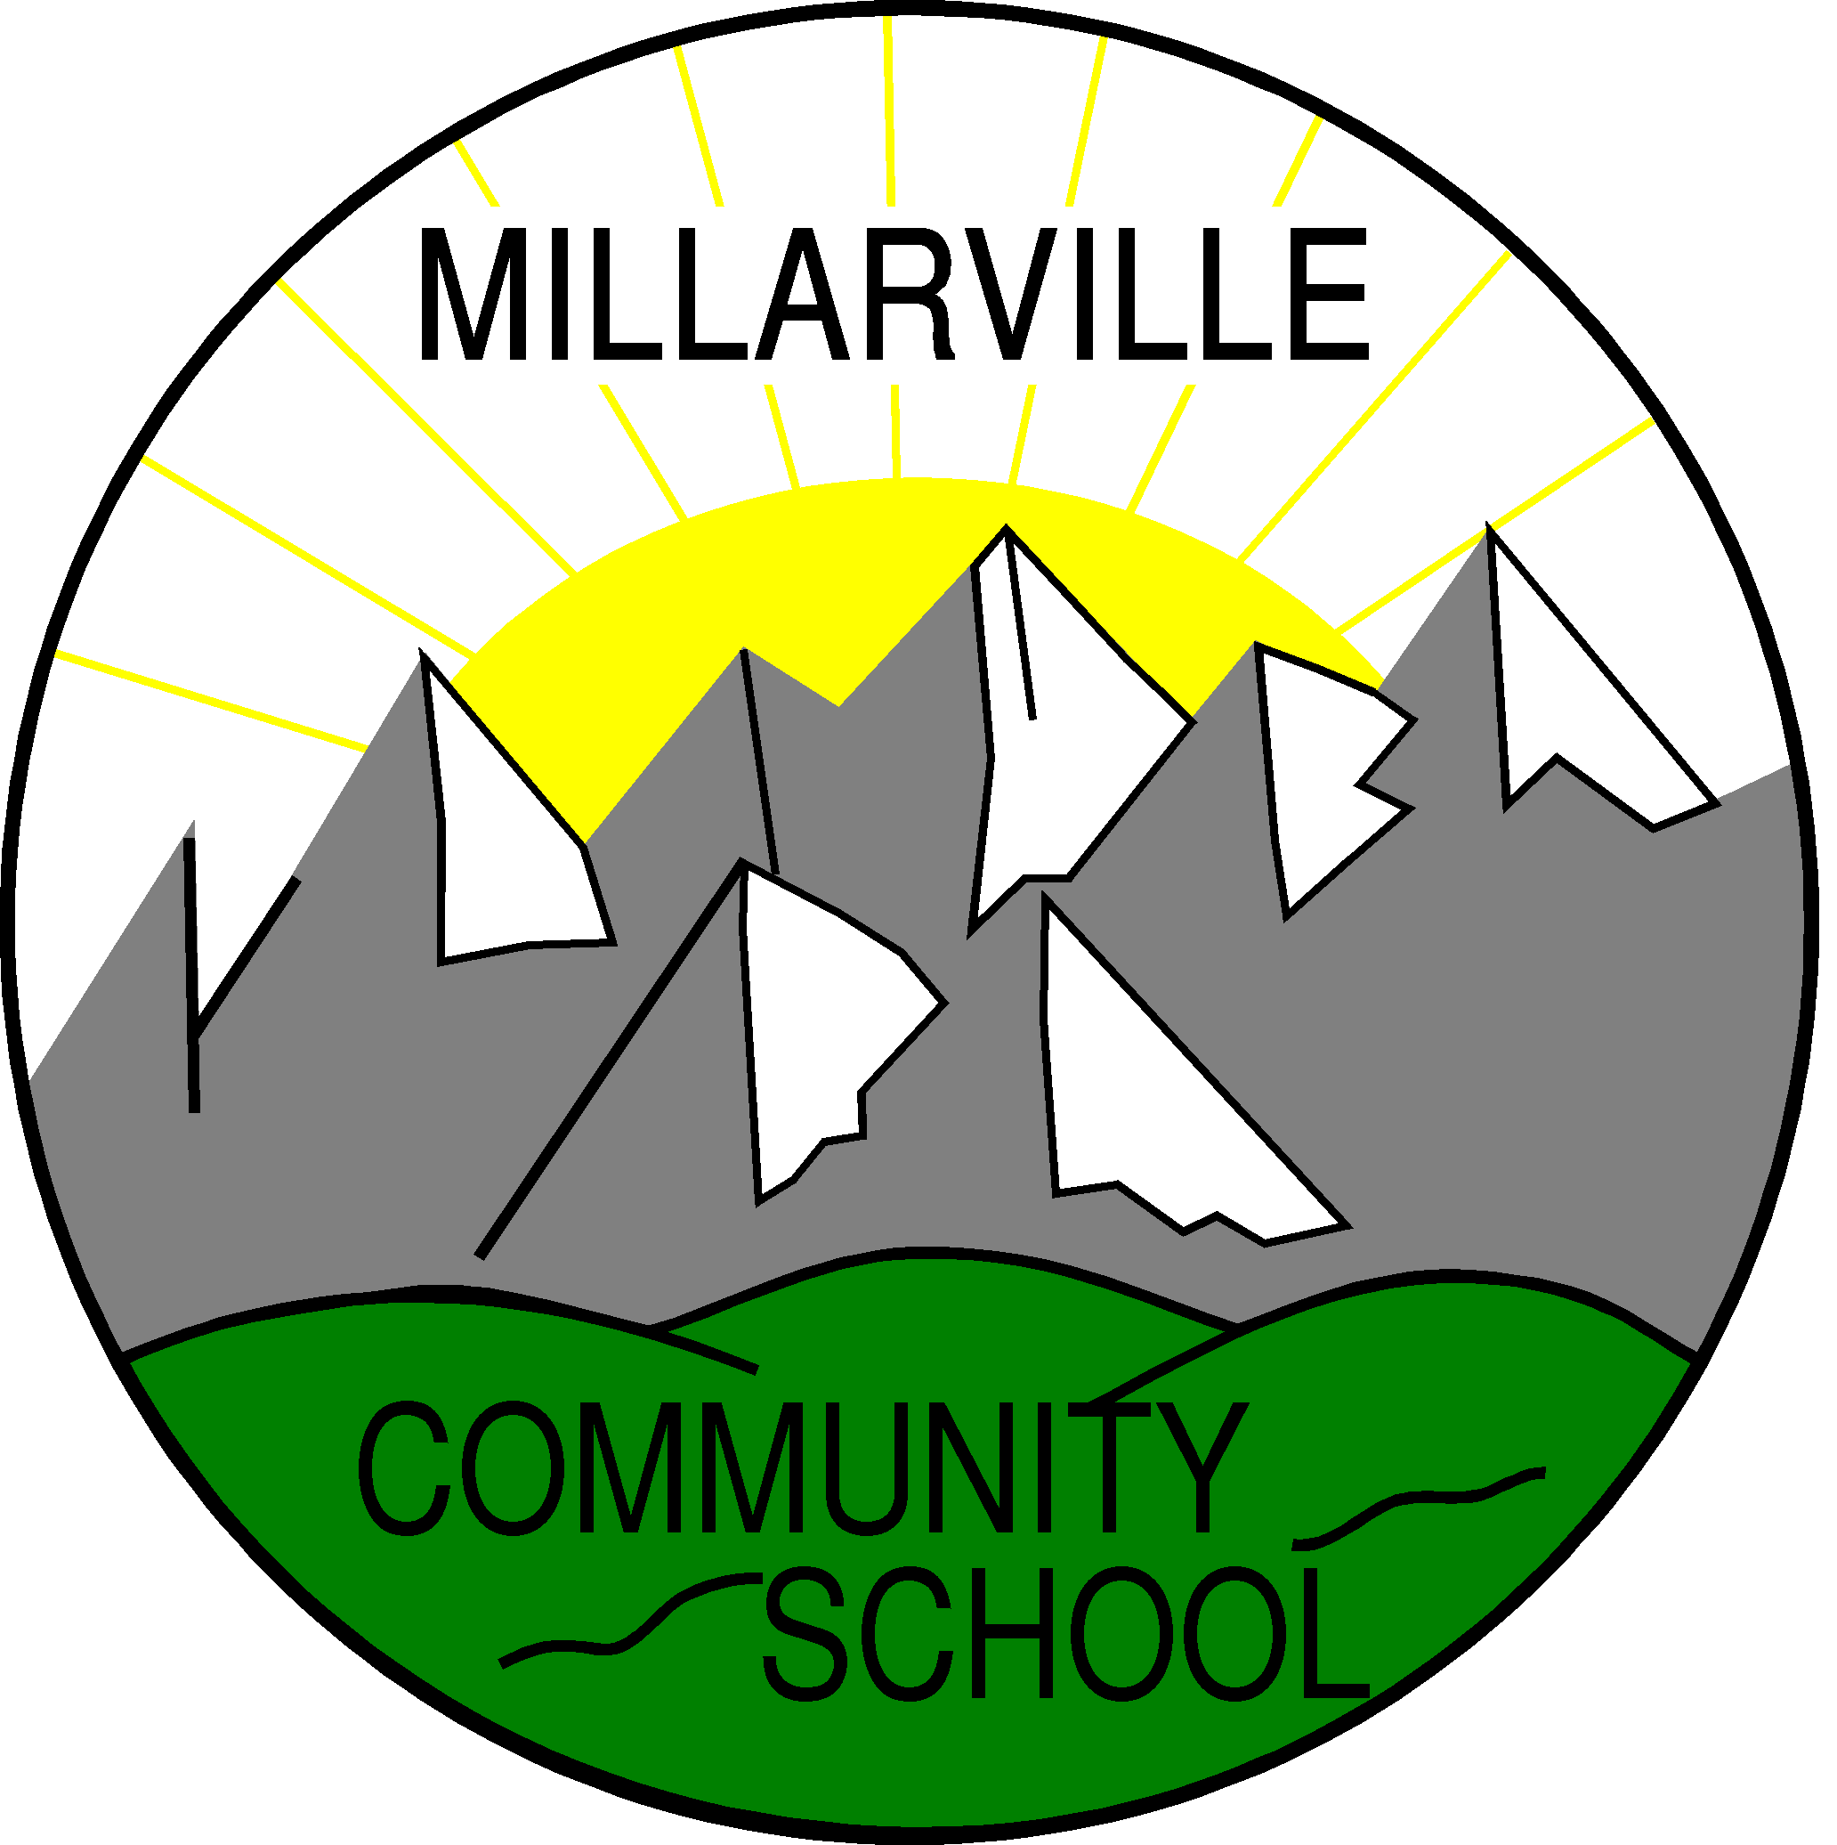

MCS Mission
To create a caring, challenging, and engaging learning environment which reflects the values and vision of the International Baccalaureate and Foothills School Division.
We strive to inspire and empower our students to think creatively and critically, pursue lifelong learning, and contribute positively to the global community

Millarville Community School
Essential Agreements

Professional Conduct

Who we are
- We believe in the development of a community of learners that actively engages and includes parents, students, and teachers in learning.
- We believe in the development of a safe and caring community of learners, built on fairness trust, and respect, that includes all parents, students, and teachers.
- We believe in the development of collaborative teams who engage in open discussions planning learning engagements, solving problems, and celebrating successes.
- We believe in being principled people who act with integrity and respect.

What we do

- We believe, as open-minded people, in the need to listen, to learn, and to reflect deeply.
- We believe in caring for and nurturing the members of our community.
- We believe in listening to seek understanding and to give others the opportunity to express their ideas.
- We believe in using our collective strengths
How we do it

- We believe in communication that provides information to parents, students, and community members sharing challenges, discoveries, and celebrations.
- We believe in the need for everyone to authentically explore, research, and inquire.
- We believe that, as internationally-minded thinkers, we feel confident to take action
- We believe that learning is a social, collaborative endeavor

Why we do it

- We believe in helping our students to become lifelong learners and develop a sense of love and passion for life.
- We believe in the development of global citizens and internationally-minded thinkers.

Communication

The staff at MCS believes strongly in the need to develop an effective communication plan. As an International Baccalaureate (IB) World School, our staff, students, and school community members are encouraged to demonstrate the attributes of the IB Learner Profile to become internationally minded citizens. These ten attributes - inquirer, thinker, balanced, reflective, communicator, knowledgeable, caring, principled, open minded, tolerant - form the basis of our school’s essential agreements.

To that end, we agree that effective communication is a shared responsibility between all of the partners who make up the school community. Consistent, daily communication promotes transparency. Research has shown that effective communication is an integral component of successful educational programs. Effective communication plans must ensure the free flow of information in both directions between the home and school. It is with this in mind that the following communication plan has been developed.

School → Home Communication

Agendas - The MCS Fundraising Society has purchased agendas for all MCS students. These are the primary information source for daily communication home. Tests, homework and assignments are kept within this agenda during a dedicated agenda time at the end of each day. Parents can use the agenda to communicate quick notes to teachers or return forms to the school. It is encouraged that parents check into your child’s agenda regularly.

Bi-weekly Millarville Messenger - This publication provides a look ahead and a look back at happenings in the school and community. Parents will receive notification of the publication every other Monday throughout the school year. Paper copies are available in the school’s office and a digital version is available on our school website. Community articles must be in on the Friday prior to each publication in order to be included.

School Website - The school’s website is the central resource for all families. Newsletters, classroom sites, our Twitter feed and other information can be found quickly on this site. millarville.fsd38.ab.ca

Classroom Websites - Each grade has a website to update families regarding current topics of inquiry, resources for home and homework assignments. Please check in with your grade’s website regularly to keep on top of current classroom events and resources to help your child at home.

Classroom Newsletters/Emails - Many teachers email their families frequently to ensure you are abreast of the latest information and news from the classroom. Please ensure your latest email address is correct with Mrs. Gregson early in the year and check your spam folders to ensure you are not missing these emails.

Twitter/Facebook - MCS has a school Twitter feed to update families and our website of upcoming events, resources and photos of what is happening around the school. A Twitter account is not needed to view these tweets, simply log onto our school website to see more. @MCSWildcats or www.facebook.com/MCSWildcats

Telephone Calls - Teachers will make telephone calls to the homes of students as the need arises. These calls will be of a positive nature as well as providing an opportunity to discuss issues of concern.

Notes or Letters - From time to time parents may receive a letter or note from their child’s teacher regarding a specific issue of importance.

Permission Forms - Anytime that a class or group of students leave the school to participate in a field trip, a permission form containing the specifics of the trip will be sent home for a parent or guardian signature. It is VERY important that these forms come back to the school ontime or your child may not be able to attend an upcoming fieldtrip. Additional forms may be found on our school website.

Memos from the Office - Memos containing information regarding specific activities will be sent home as necessary.

Home → School Communication

Parents/guardians are encouraged to maintain regular communication with the school using a variety of means. The primary point of contact about concerns about your child’s learning, social development or other points is your child’s classroom teacher. If you have contacted the teacher and feel an issue has not been resolved, please feel free to contact Mr. Gibson. MCS has an open door policy and welcomes parents to our school. However, for safety reasons, we ask that you sign in at the office when you arrive. PLEASE contact the school prior to 9:00 am to report your child absent.

Agendas - Quick notes and appointments can be passed through your child’s agenda.

Telephone - Parents are able to call the school (403-938-7832) in order to obtain information or to arrange meetings with staff. Please note that teachers will not be called out of class to answer telephone calls unless they are of an emergency nature.

Meetings - Parents can arrange a meeting with a teacher or school administrator by calling the school.

E-mail - Parents are able to contact teachers via email. These email addresses are available on the school website if you require.

Policies

Academic Honesty Policy
It is the opinion of the staff at Millarville Community School that using this particular attribute of the Learner Profile provides the most comprehensive definition of what academic honesty and integrity can be. We promote and uphold the following beliefs and practices:

- Students take responsibility for their own work.
- Students work individually unless otherwise instructed.
- Students recognize the difference between individual work and group work.
- Students give credit to other people working in the group.
- Students do not copy other people’s work.
- Students reference sources according to agreed‐upon (age‐appropriate) bibliographic formats for each grade.
- Students use information technology and library resources responsibly.

We agree that this policy will be reviewed and/or updated annually in the spring before students in Grade 5 begin Exhibition.

Assessment
As an IB-authorized school, the staff at MCS involves all of their students in the PYP, regardless of their learning needs. The staff supports the IB recommendation that the PYP is “whole-school approach". The staff at MCS supports each student and will make any necessary accommodation for students with special needs.

We agree that this policy will be reviewed and/or updated annually in the spring.

Language Policy

The MCS Staff agrees that language learning at the school will:
- be consistent and developmentally appropriate
- support the development of skills and understanding in the language of instruction (English) as well as the additional language offered at the school (French)
- be differentiated to meet the needs and learning styles of all students including but not limited to those need special services
- be reflected in the programme of inquiry, transdisciplinary planners and lesson plans

The MCS staff agrees that they will
- work with all students so they may achieve mastery of the essential language skills – reading, writing, listening, speaking and viewing
- utilize a variety of materials to enhance the development of language skills

We agree that this policy will be reviewed and/or updated annually in the spring.

